Contents

Buffers 1

PTx.2% (1L) 1

PTwH (1L) 1

Blocking/Permeabilizing Solution (50mL) 1

Secondary antibodies 2

Sample Collection 2

Immunolabeling 2

Clearing tissue 2

Tissue check 3

Antidbodies tested 3

Light Sheet Imaging 3

Quantification 3

References 3

# Buffers

### PTx.2% (1L)

* 100mL PBS 10X (900mL H2O)
* 2mL Tween20 (iDISCO uses tritonX)

### PTwH (1L)

* 100mL PBS 10X
* 2mL Tween-20
* 1mL of 10mg/mL Heparin stock solution

### Blocking/Permeabilizing Solution (50mL)

* 42mL PTx.2%
* 3mL of Donkey Serum
* 5mL of DMSO
* 0.1% Sodium azide (0.05 g)
* raise to 1% Tween20 (add 0.4mL)

## Secondary antibodies

Do not use chemical dyes, use ALEXA dyes or fluorescent proteins only (communication with Klingberg)

# Sample Collection

1. Anesthetize the mouse.

2. Perfuse with 10mL PBS.

3. Perfuse with 10mL 4%PFA/PBS.

4. Dissect the brain/organ and trim to the appropriate size.

5. Fix in 1xPBS/4%PFA at 4°C, 48hr with rocking.

6. Wash in PBS with shaking: RT 30min x 3times.

# Immunolabeling

After fixation and wash:

|  |  |  |  |  |
| --- | --- | --- | --- | --- |
| Tissue | Bleach 5% H2O2 in PBS1 | Block/Perm soln | 1° antibody, in Block soln | 2nd antibody, in Block soln w/o Gt serum |
| Whole Brain (Klingberg) | O/N rock, wash PTx.2% | 7 days rock @ RT | 7 days rock, wash PTwH @ RT 3x then O/N | 2 days rock, wash PTwH @ RT 3x then O/N |
| Whole Brain (iDISCO+) |  | 2 days |  | 2 days |

1. Bleach in fresh 3%H2O2 in PBS (1 volume 30% H2O2 to 5 volumes PBS), overnight at RT°C.

Nutating rocker (<https://www.fishersci.com/shop/products/nutating-mixer-fixed-speed120v/88861041>):

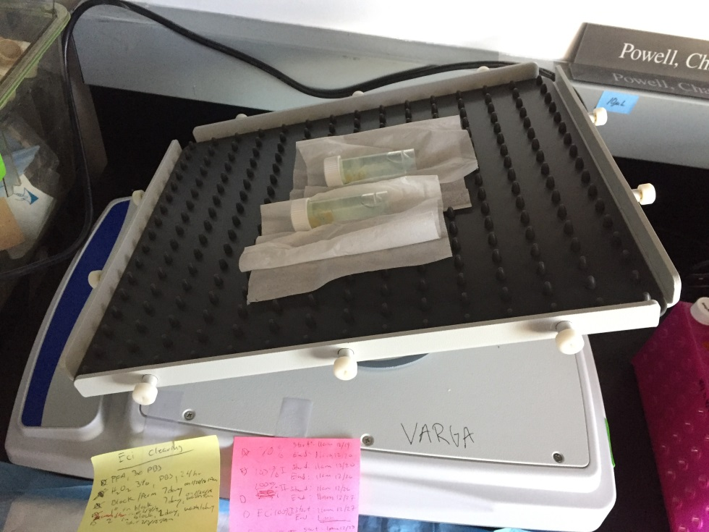

From Blocking step on, use light shield.

# Clearing tissue

After immunolableing:

|  |  |  |  |  |
| --- | --- | --- | --- | --- |
| Tissue | 35% EtOH + 2% Tween (pH 9) | 70% EtOH + 2% Tween (pH 9) | 2x 100% EtOH + 2% Tween (pH 9) | 2x 100% ECi |
| Brain | 24hr | 24hr | 24hr each | 4hr then O/N each |
| Whole Brain (iDISCO+) |  |  |  |  |

# Tissue check

How clear does it look?

Attempt #1 on 121817 🡪 Yellowish 🡪 minimize air in tube during dehydration/ECi

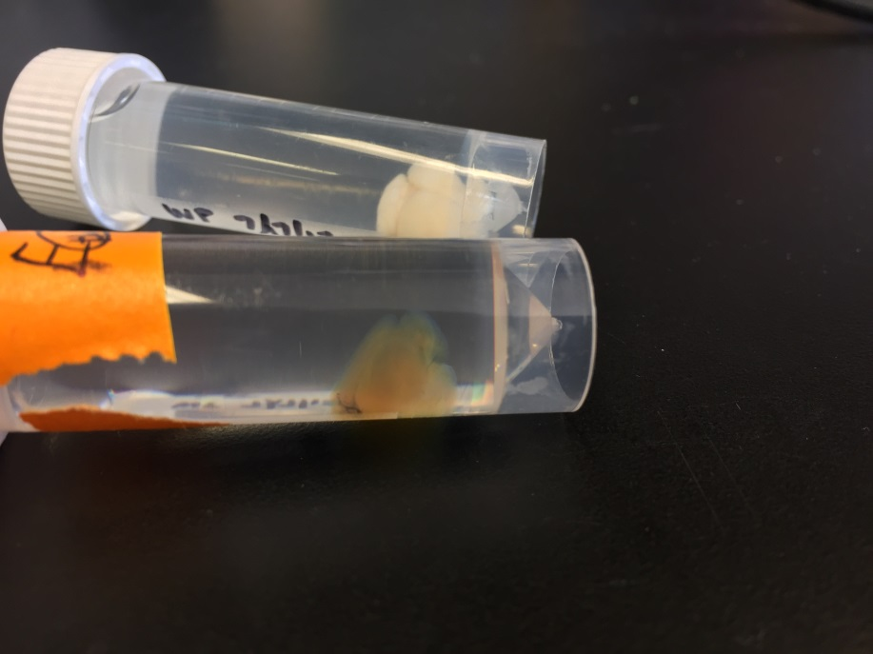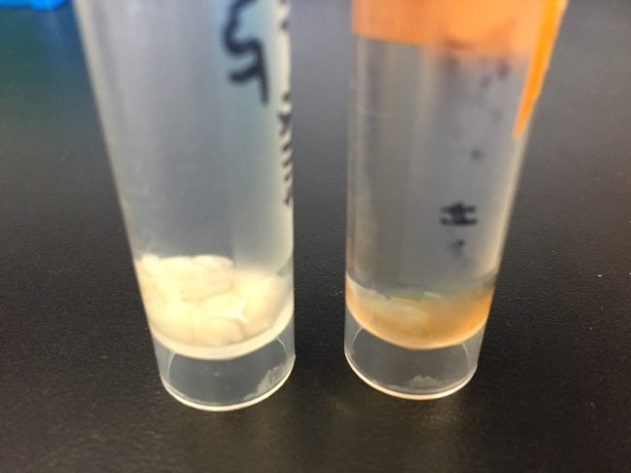

# Antibodies tested

Primaries:

* Tyrosine hydroxylase: 1:100 in 5 mL vial 🡪 50 uL/vial
* AT8-human p-tau 🡪 (attempt after TH)

Secondaries:

* Secondary Gt Anti-Rb AlexaFluor 647: 1:100 in 5 mL vial 🡪 50 uL/vial

# Light Sheet Imaging

Defer to Sijie and Nikos

# Quantification

Learn clearmap (but I’ll most likely need access to the Microscopy Core’s server to run a python script):

<https://rawgit.com/ChristophKirst/ClearMap/master/docs/_build/html/index.html>

Test on trial dataset first (Allen Institute Mouse ref brain).

# References

* Klingberg et al., Fully Automated Evaluation of Total Glomerular Number and Capillary Tuft Size in Nephritic Kidneys Using Lightsheet Microscopy, 2017.
* Renier et al., Mapping of Brain Activity by Automated Volume Analysis of Immediate Early Genes, 2016.
* Renier et al., iDISCO: a simple, rapid method to immunolabel large tissue samples for volume imaging, 2014.
* <https://idiscodotinfo.files.wordpress.com/2015/04/whole-mount-staining-bench-protocol-methanol-dec-2016.pdf>